Preparation for Milking:
- Bring from the house: milking bucket and lid, line filter, big Stainless milk jar with lid
- Put on gloves.
- Hook inflations and trap lines to lid, adding filter in between inflations and lid, and attach hose between milk bucket and air trap.

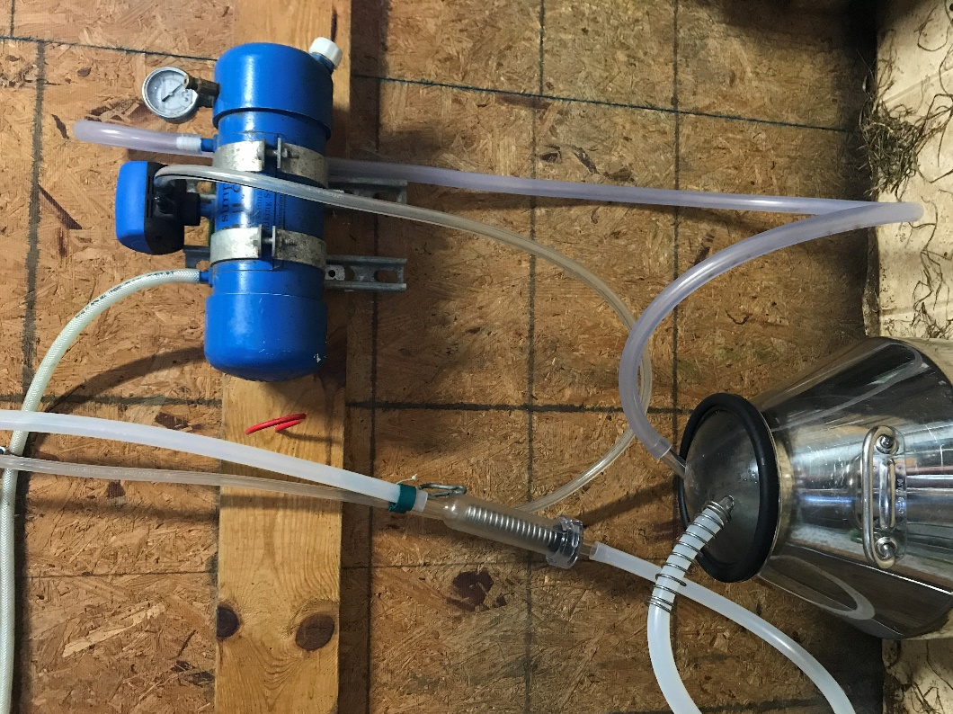

- Add 5 qt water to wash bucket. Add ¼ cup of bleach to water. Run sanitizing water through the lines. Dump milk bucket and reassemble.
- Place filter on in-line filter apparatus.

Milking:
- Bring in goats
- Close the headpiece and give the goat feed (instructions above feed bin)
- Strip first stream of milk to look for clumps.
- Dip teats in green teat dip solution. Wait 10-15 seconds
- Wipe teats off with a paper towel (one per teat).
- Turn on vacuum and place inflations on teats. Check that milk is flowing. After about 30 seconds, massage udders to release milk.
- When milk flow slows to a trickle, break seal by pulling down on green clips on inflations, turn off vacuum. Spray teats in brown dip solution, and escort her out.

Cleaning Preparation - While Milking:
1. heat 2 kettles simultaneously at lowest temp. When they finish, pour both into white bucket and close the lid. (rinse water – 100-115F)
2. heat one kettle at a time at 3rd temp (179?). When one finishes, do the second. (detergent water)

Vacuum pressure should be between 11 and 13!

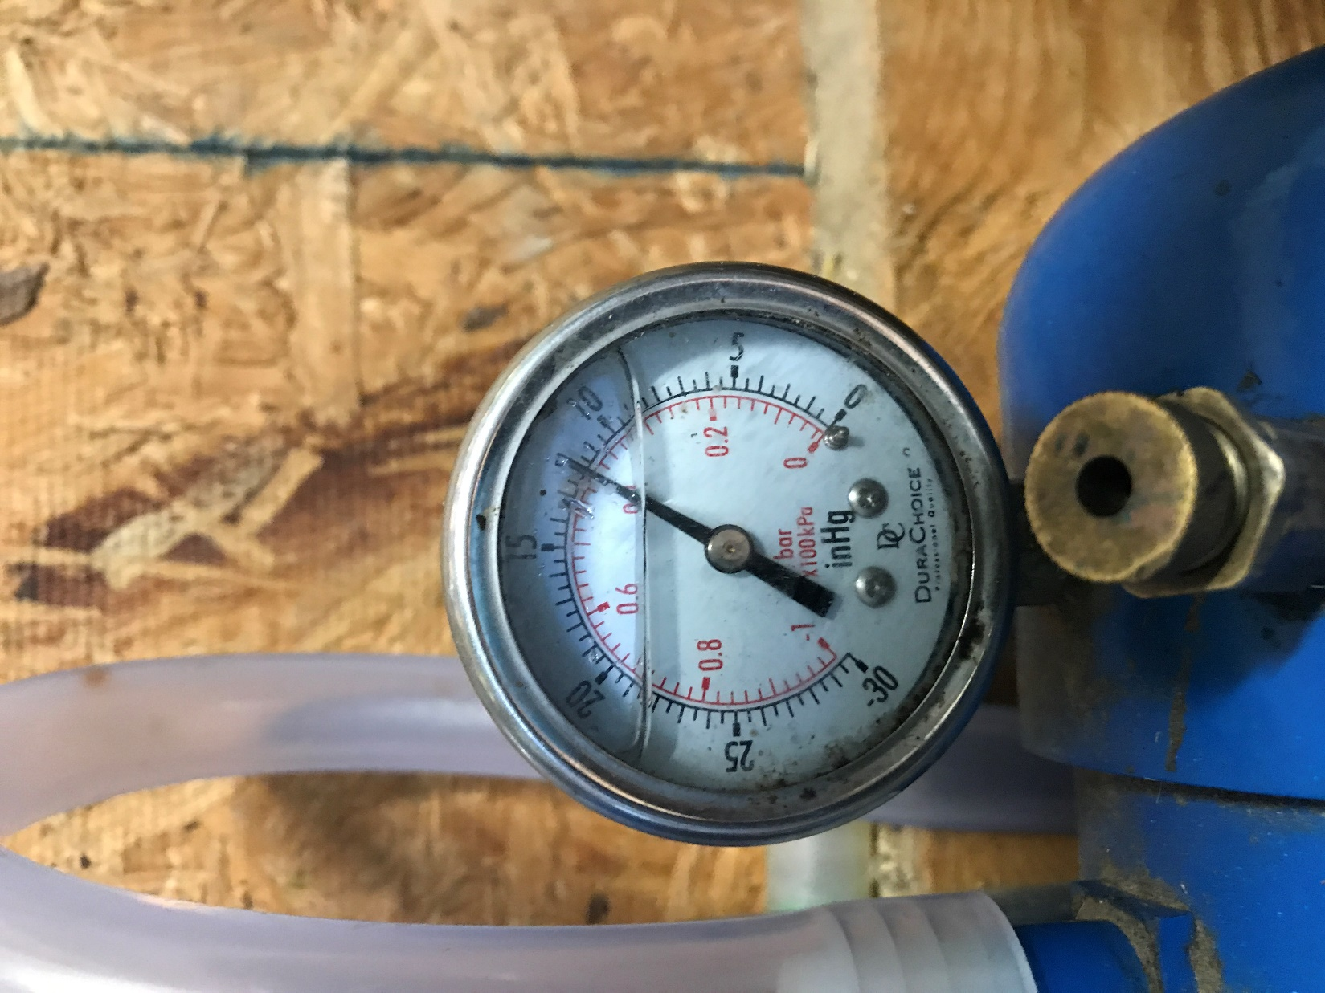

Cleaning Procedure:
- Transfer milk into stainless milk can.
- Rinse lukewarm wash water through inflations. Empty milk bucket into sink.
- Refill kettle and turn on to 155F temp.
- Fill bucket to 5 qts (both kettles) with hot water (~160F). Add 2 scoops of Duo-Pfan powdered detergent. Run all through inflations. pour water back into bucket, repeat through inflations. Empty into mop bucket to mop the floor later.
- Acid rinse (4 squirts (pH 3-4) into 5 qts of warm water (1 kettle of hot, to first line from faucet). Empty milk bucket into sink.
- Hang inflations to dry on the top hook. Spray a paper towel with bleach water, wipe down outside of inflations and tubing.
- Spray and wipe down milk stand with bleach water.
- Sweep floor, empty trash. Mop with warm wash water from milk bucket.
- Take milk to house, pour.
- Wash milk can and jars with hot soapy (foaming dairy soap) water, followed by a bleach rinse (1/2 gallon water, ½ tbsp bleach). Dry upside down.

Maintenance Schedule:

Weekly:
- check oil on vacuum pump and refill when necessary
- wipe down vacuum pump and shelves, dust milk room
- suck a little of each cleaning solution into air reserve tank, open between to drain. After bleach solution, open to air dry.

Monthly:
- take apart milk machine (all tubing, liners, inflations, etc) and deep clean all components:
- rinse with lukewarm water
- soak for 15 minutes in hot soapy (foaming dairy detergent) water
- scrub with brushes, rinse with warm water
- soak for 10 minutes in 100 ppm bleach solution (1 gallon water, 1 tbsp household strength bleach)
- air dry, put back together. Sanitize right before next use.
- inspect all equipment for rust and milkstone

Yearly:
- replace all tubing, Y-s, inflations

